Presented by
GRAPHR APPLICATIONS, LLC
www.graphrapp.com

Betsy Goodfriend and Pawan Jajoo

Creating A Virtual Classroom
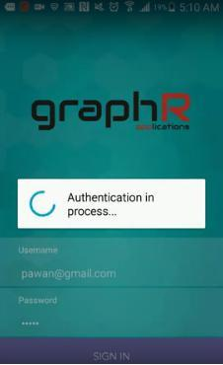
Once a school or school district signs up for GraphR, teachers can download their version of the app directly from the marketplace and log in using their credentials. Students have their own version of the app and can also download it directly from the marketplace and login with school-provided credentials.

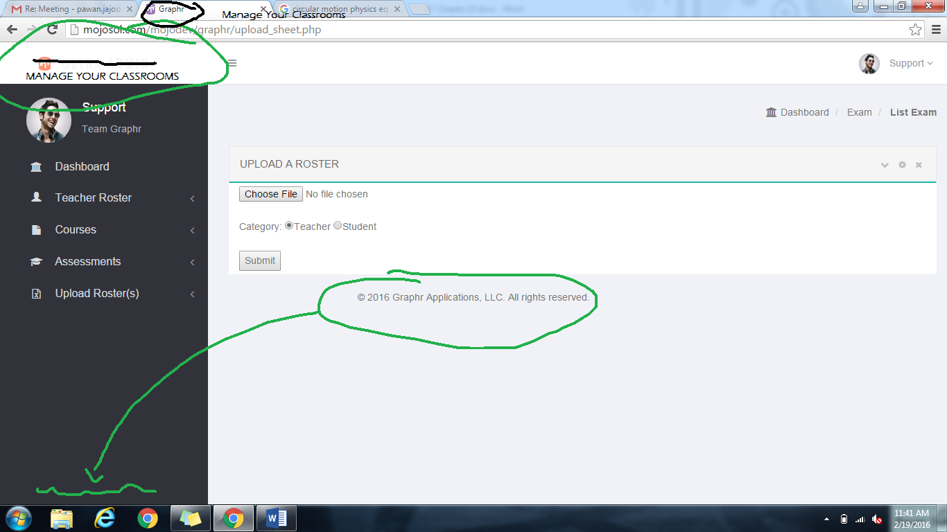
Teachers also have access to the GraphR Web Panel with their credentials. This is where they can upload class rosters or add/edit/remove students individually to their virtual classrooms.

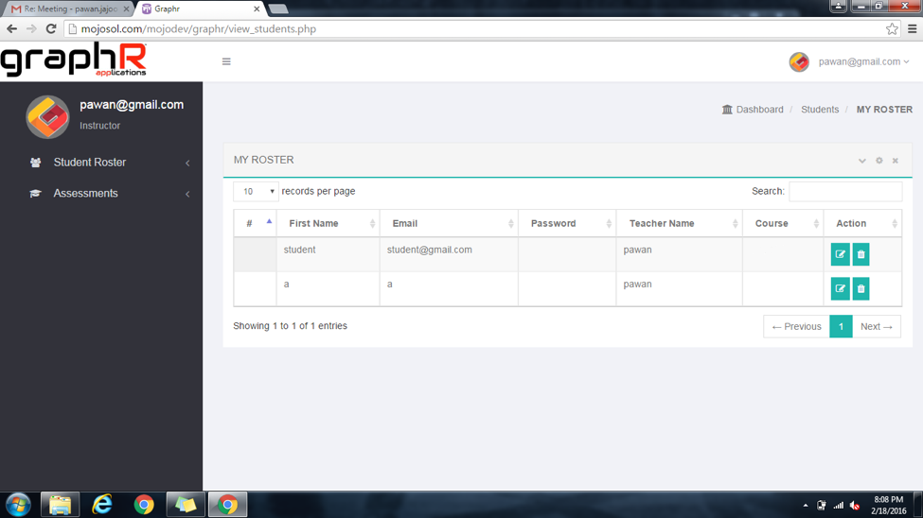

Screenshots of the GraphR Web Panel are shown for reference.

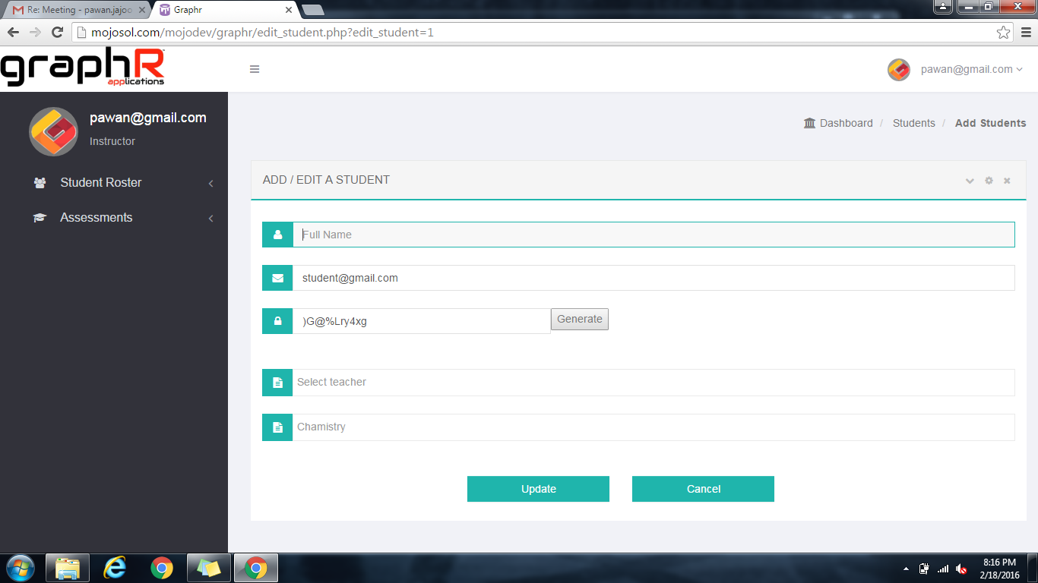
Customizing An Assessment For Test Mode
The GraphR Web Panel also goes hand-in-hand with our proprietary Test Mode. Test Mode also allows teachers to curate certain functionalities of our multi-function calculator based on the testing material. For example, if a quiz or test is trying to assess a student's ability to graph, teachers can restrict their classroom to a certain type of calculator for the duration of the exam using their administrative login privileges.

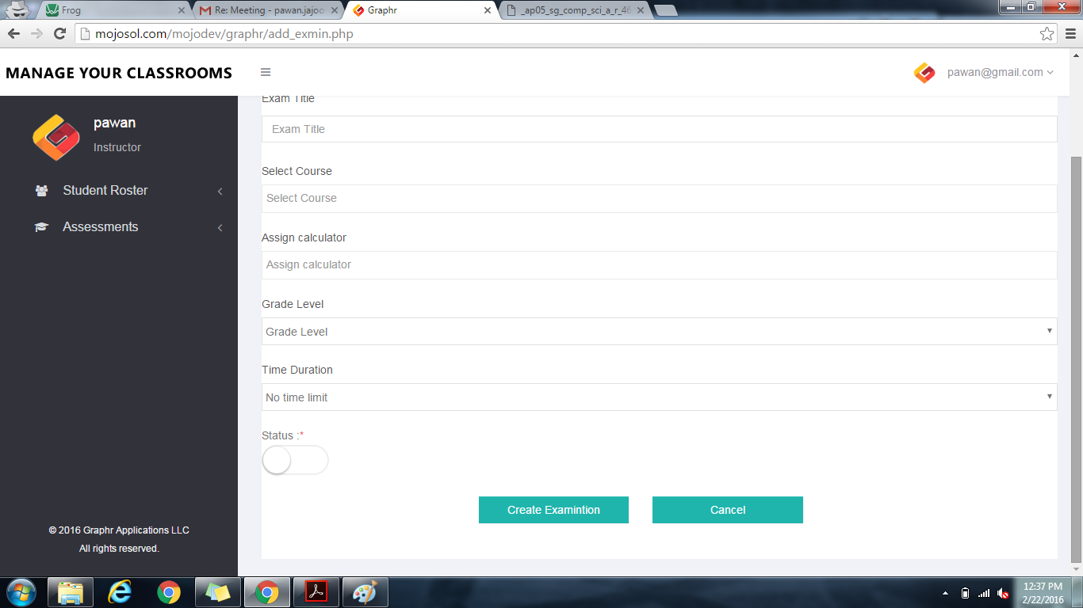

Teachers can even create entire exams and answer keys from our Desktop interface, and assign a particular type of calculator to each question. This is useful if an exam is testing multiple skills at the same time (i.e. graphing and solving matrices). Traditionally, that scenario would require taking the test in separate segments and / or requiring students to purchase two or three different types of calculators, wasting both time and money for everyone involved.

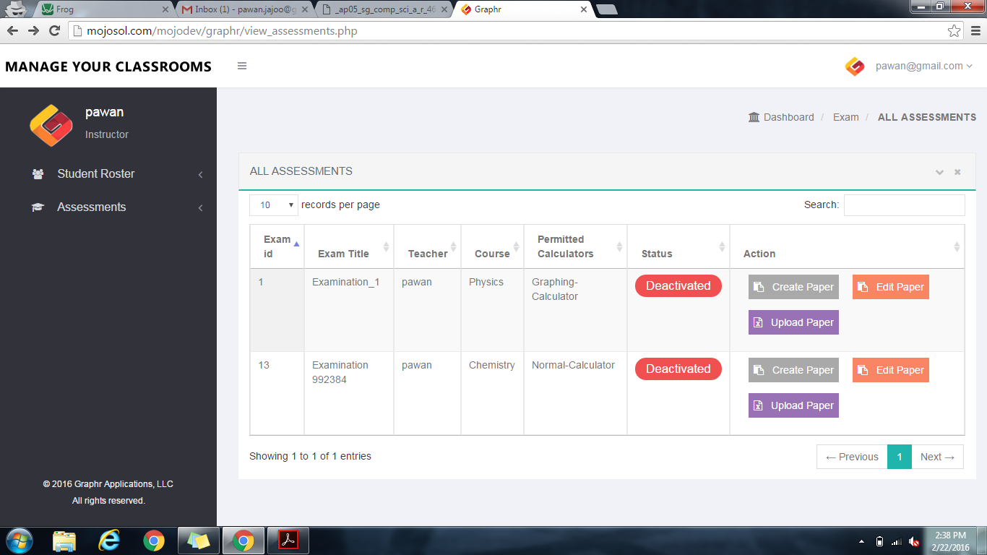

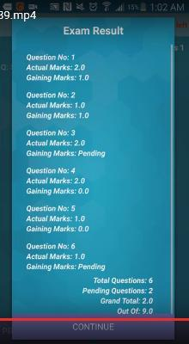
Students and teachers alike find that mathematical process is inconvenient to write out, and even more tedious to make sense of and grade.​ That's why Graphr's Test Mode feature offers to log and organize each student's calculator input and logic in an easy-to-read, digital text file format.

If the exam is hosted on our interface, the app can even grade final answers (weighted / unweighted) for accuracy, awaiting the teacher's independent assessment of the student's logic and critical thinking skills. Thus, Graphr can help teachers identify top concerns and achievements related to their students.

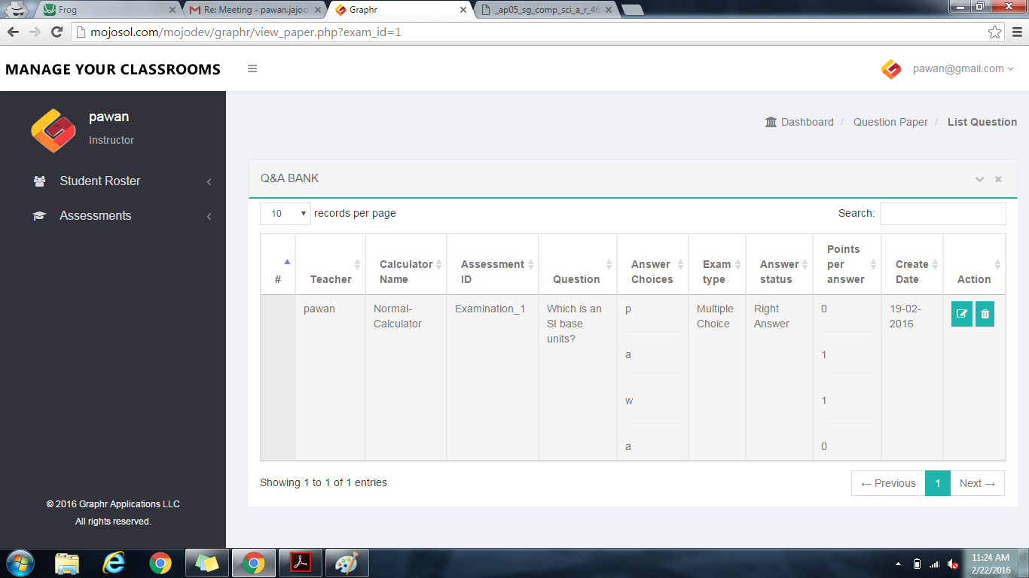
Identifying Suspicious Behavior
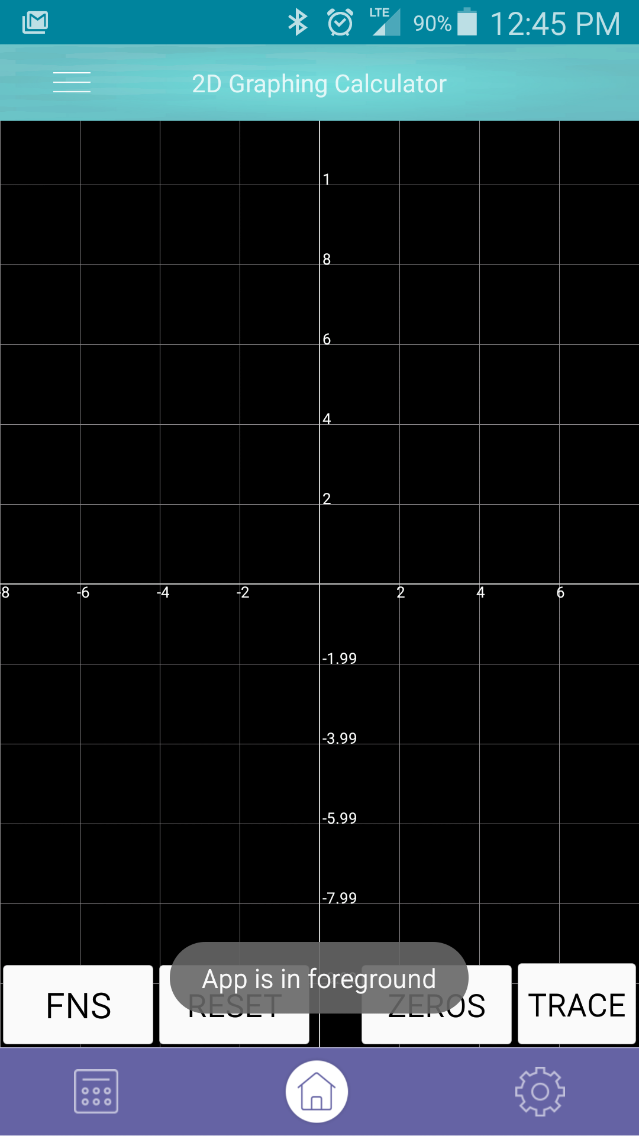
Outside of our patent-pending "Test Mode," Graphr can be used offline like any other multi-function calculator. Test Mode is activated as soon as a student logs in to a classroom and / or begins an exam. This, of course, requires Internet connection via school Wifi or a cellular data network in order to make use of our secure, Cloud servers.

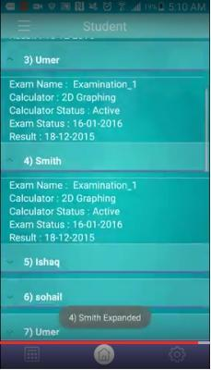
The teacher then receives in-app notifications if the app detects it is not the primary application running on the student's device (if a student is taking an exam and exits the app, the exam also closes). In this way, students are not locked out of their device in case of an emergency, and disciplinary measures (if any) remain at the discretion of the virtual classroom's administrator.

Additional Features To Further Success
To enhance the user experience and promote creativity and individuality in the learning environment, GraphR offers in-app purchases of calculator skins, themed backgrounds, etc. The GraphR App is available on devices running at least Android 4.1, as well as devices running iOS 7 and onwards.


